Bukit Batok Library reopens at twice the size, as Singapore’s first library with an immersive soundscape
The soundscape layers everyday Bukit Batok sounds in ambisonic 3D surround, flowing from Level 1 to 2

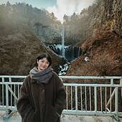

Written by
Mingli Seet
Contributor, Time Out SingaporeMonday 30 March 2026
Share
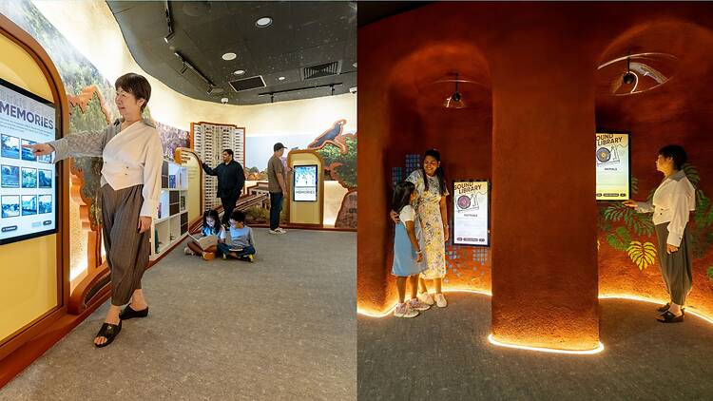Photograph: NLB | (Left) Time Cavern (Right) Sound Library
Bukit Batok Library is back, and it has officially levelled up. Now spread across three floors at West Mall, the library has grown to over 2,700 square metres, nearly doubled seating, and added more spaces for reading, discovery, and just escaping the mall bustle.
The standout feature, though? Sound. For the first time in Singapore, a library is using immersive audio to complement the reading experience. The SingLand Soundscape, created by Singaporean sound artist Mervin Wong, layers everyday Bukit Batok sounds in ambisonic 3D surround, flowing from Level 1 to 2. Selected spots also showcase curated audio and visual material from NLB’s archives, bringing the stories and memories of Bukit Batok to life.
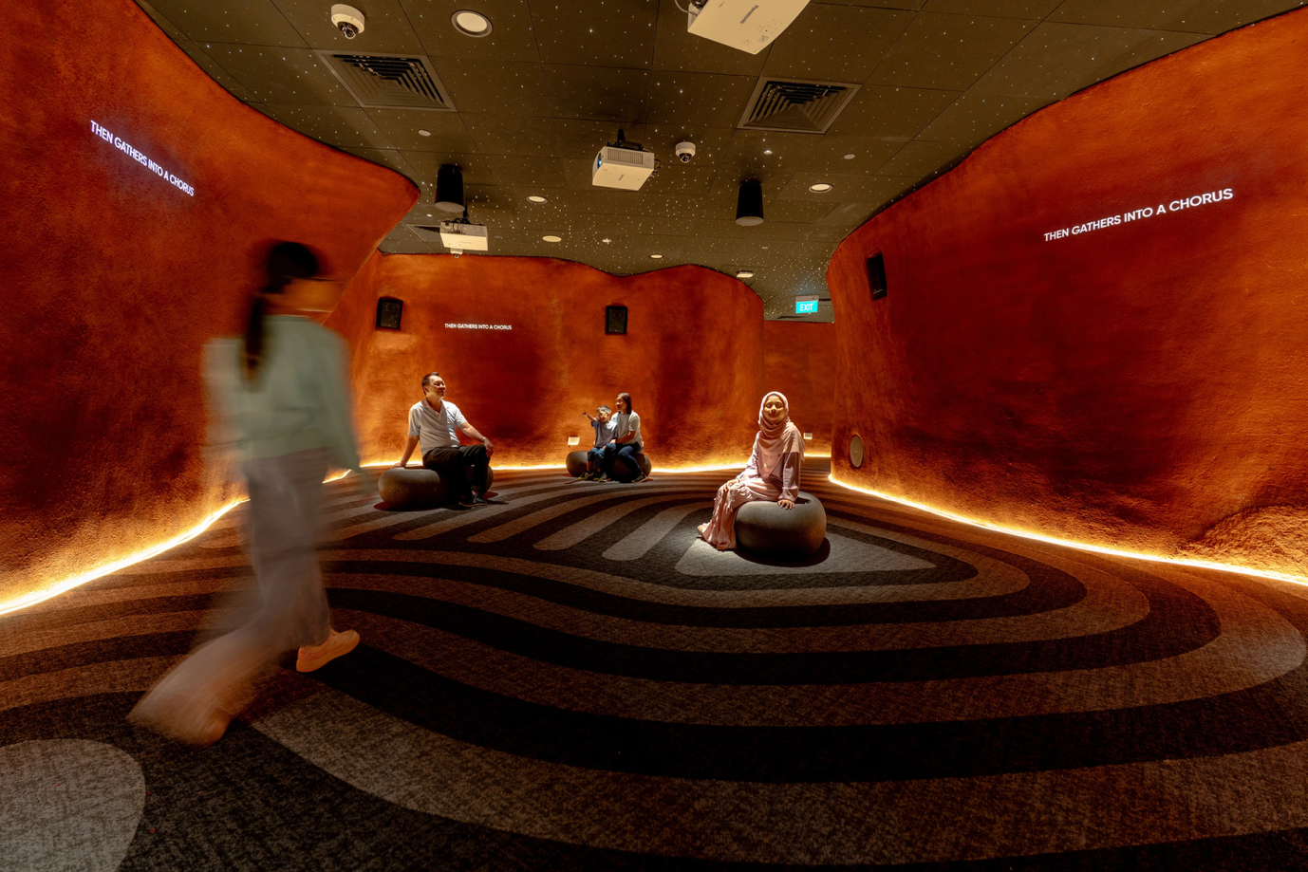Photograph: NLBSound Cave
There’s also a ‘Scan-n-Discover’ feature, where you can scan a book’s QR code to instantly see related physical and eBook recommendations. Infinite Shelves – an interactive system that extends physical shelves into a world of digital books – also carries popular genres like Travel, Health, and Adult Fiction into interactive eBook displays. Audiobooks curated by NLB librarians are accessible via QR codes and the NLB Mobile App, letting you borrow digitally beyond the limited physical copies.
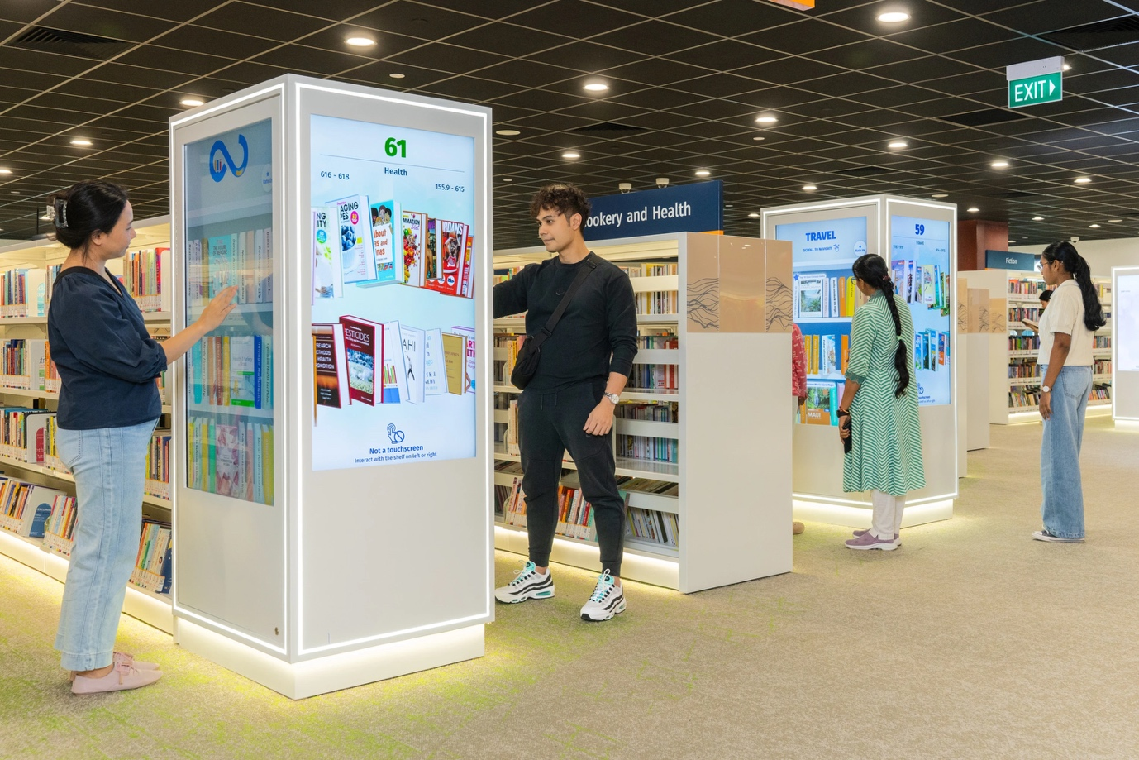Photograph: NLBInfinite shelves
Bukit Batok Library has also extended its hours so you’ll be able to explore levels one to three from 9am to 9pm, with staff-assisted services from 11am and select zones open until 10pm.
Visit the National Library Board’s webpage for more information.
READ MORE

